# Configure Dev Environment and Source Control Repository

1. Download the source code as zip file from <https://github.com/jintov/Product-Assets> and extract it to a local folder on your machine (say **D:\MST\Services\ProductAssets**)
2. Open node.js command prompt, go to “D:\MST\Services\ProductAssets” folder and run the following command to set up all module dependencies:

**npm install**

1. Run the following command to start the server

**node server.js**

1. Access the following URLs to verify that all endpoints are working

<http://localhost:8002/assets>

<http://localhost:8002/assets/47400656109>

<http://localhost:8002/swagger>

<http://localhost:8002/docs>

1. Set up a repository called “**Product-Assets**” within your GitHub account ([https://github.com/{username}/Product-Assets](https://github.com/%7busername%7d/Product-Assets))
2. In the Node.js command prompt, run the following commands:
   1. Initialize the local Git repository

**git init**

* 1. Configure the remote GitHub repository

**git remote add productassets** [**https://github.com/{username}/Product-Assets**](https://github.com/%7busername%7d/Product-Assets)

* 1. Add source code to local Git repository

**git add .**

* 1. Commit all code changes

**git commit -a -m “initial version”**

* 1. Push code to GitHub repository. When prompted for username and password, enter your GitHub credentials.

**git push productassets master**

1. Verify that code has been checked into GitHub
2. When any changes are done, run the following command to check-in the code again

**git commit -a -m “2nd version”**

**git push productassets master**

# Create a new API App in Azure

1. Create a new API App as described in the section “Create a new API App” at <https://docs.microsoft.com/en-us/azure/app-service-api/app-service-api-nodejs-api-app#a-idcreateapiappa-create-a-new-api-app>. Give the app a unique name… say “**pg-products-assets**”. The steps must be put here including any required screenshots.

# Configure CI/CD

1. Go to Deployment Options of the newly created API App

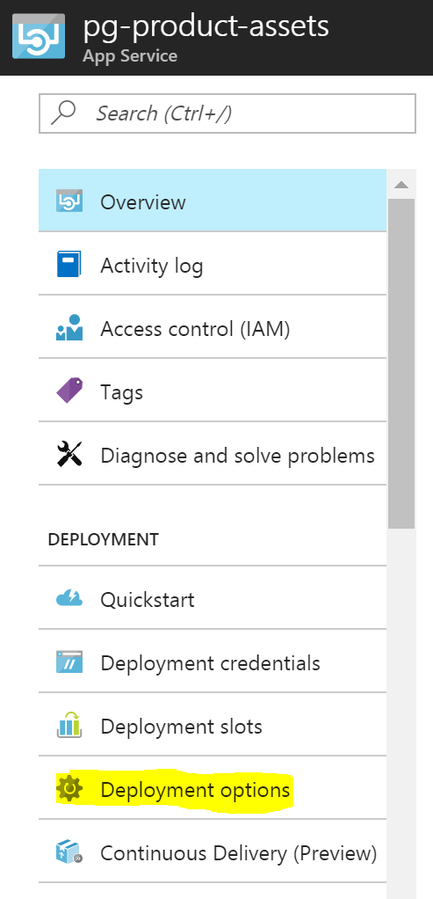

1. Choose GitHub as the deployment source

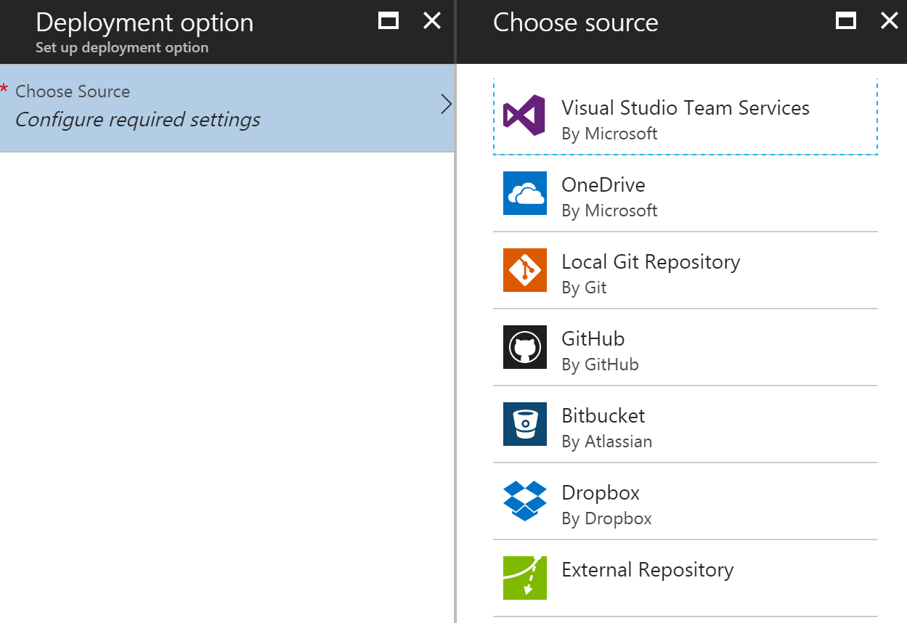

1. Click on Authorization 🡪 Authorize to authorize your GitHub account access to Azure Management Portal. Enter credentials if prompted.
2. Configure the GitHub project (Product-Assets) and the branch (master)
3. After a short while, the code from repository would have got deployed. Verify the same using the following URLs:

<http://pg-product-assets.azurewebsites.net/assets>

<http://pg-product-assets.azurewebsites.net/assets/47400656109>

<http://pg-product-assets.azurewebsites.net/swagger>

<http://pg-product-assets.azurewebsites.net/docs>

1. Make any code changes (like adding a new asset into the JSON file) and push to GitHub. The service should be automatically re-deployed in Azure in a short while.